The sound system is developed using several tools and components. To come up with an effective sound system, these components and tools should be availed and a given procedure needs to be followed step by step to come up with the design. This paper will explain what tools hardware and software preferences needed to develop an effective sound system without wasting resources and money. It also aims in creating a purchasing plan
To start with, we need to come up with a reasonable budget that will be able to complete the full installation of the sound system software. We need to have all the components in place. We need a microphone (wired and/or wireless), a mixer, and a power amplifier. Loudspeakers and all the necessary cabling are also essential in this process. In this case, we will take a wired microphone to make our budget shallower.
Secondly, there’s a mere need to select a room that will sort the organizations of the speakers' system and that will provide the optimum, conditions for the machines. The photo below clearly shows a well-organized room with the sound system. The room should contain enough space to allow the smart organization of the sound system components. Moreover, the room should have infrastructure that will allow proper projections of sound waves, which will include furniture and other types of hardware.
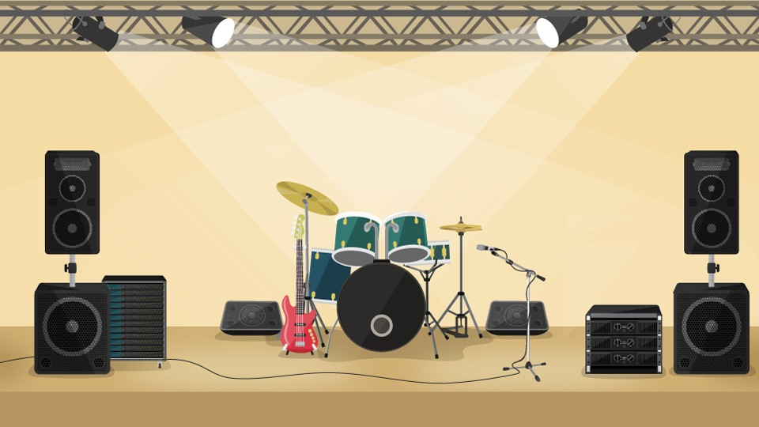

The system will contain features that will allow the client to easily have control over the system. To save some cash, we will not develop a different electrical structure. The system will contain various portable inputs including the loudspeaker input as well the wired microphone’s input. This will have the sound system arranged as shown in the following diagram.
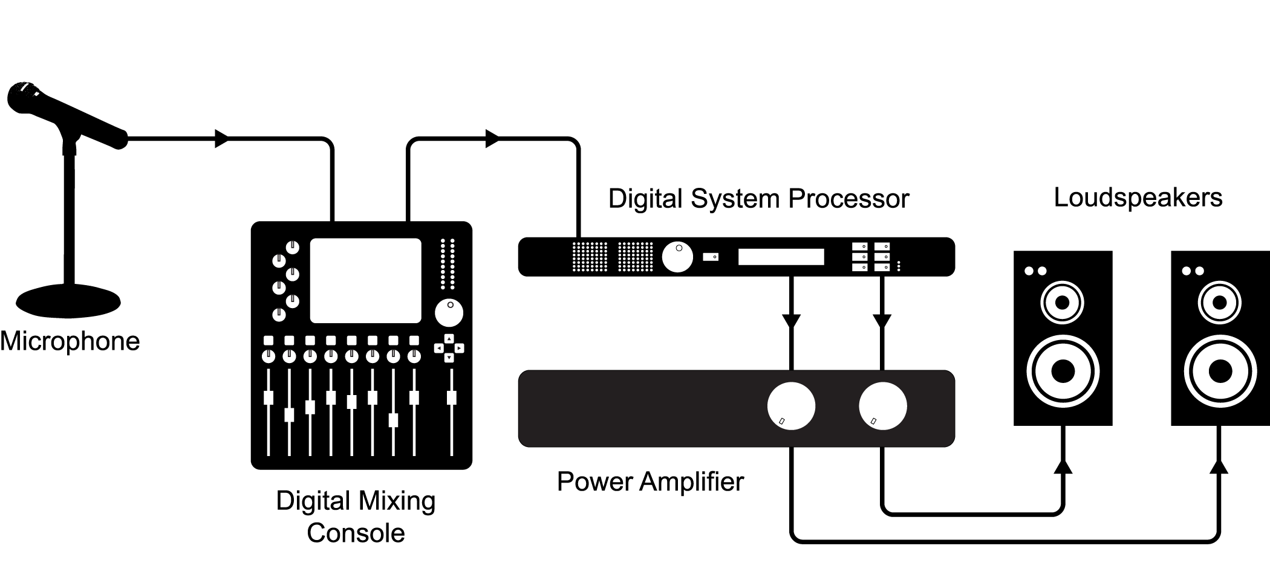
The above diagram makes all the essential sound system components that we installed clear. With the above organization of the components in the proposed room, the sound system will effectively function and generate the desired sounds. Its maintenance measures include a UPS machine that will provide power when there is the unavailability of electricity. As well, we may use an electric adapter to avoid spoiling of the power amplifier due to electrical shots that may occur.

